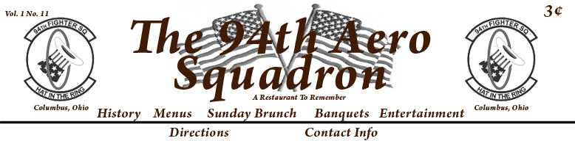

Banquet Dinner Sit Down
All sit down entrées are served with house salad and warm rolls.
All dishes served with Mashed Potatoes and Chefs selection of Vegetables.

Sergeants Prime Rib………………………………………………………………………….…..$31
10oz portion of our slow roasted specialty served with au jus.

Generals Prime Rib……………………………………………………………………………… $37
16oz portion of our slow roasted specialty served with au jus.

New York Strip…………………………………………………………………….……..………. $36
The King of Steaks Hand cut onsite and char grilled to perfection.

Filet & Scampi……………………………………………………………………………..…………………..$44
Filet Mignon char grilled and served with Jumbo Shrimp Scampi.

Farmhouse Chicken………………………………………………………………………………$25
Marinated boneless breast of chicken topped with smoked ham and cheese crowned with
demi-glaze.

Chicken Scaloppini………………………………………………………………………………. $25
Lightly pan fried chicken sautéed in Olive oil. Topped with mushrooms, spinach and sun dried
Tomatoes and finished with lemon mustard cream sauce.

Chicken Marsala…………………………………………………………………………….….…$25
Grilled breast of chicken topped with demi-glace and mushrooms.

Teriyaki Chicken……………………………………….………………………..……………..…$25
Grilled marinated breast of chicken topped with tangy teriyaki sauce, served with your
choice of rice, mash potatoes or vegetables.
Fresh Atlantic Salmon……………………………………………………………………………….………$28
Filet of Salmon roasted and crowned with extra virgin olive oil and topped with red pepper sauce.

Penne Pomodoro………………………………………………………………………………..……………$23
Quill pen shaped pasta tossed with our fresh tomato basil sauce.

Vegetable Stir Fry…………………………………………………………………………………..…………$23
Oriental cut vegetables and cashews stir-fried. Finished in a tangy oriental sauce served over rice or pasta.

Shrimp and Scallop Penne………………………………………………..………………………………$27
Shrimp, scallops and penne pasta tossed in light lemon wine and garlic butter sauce.

Lobster and Shrimp Linguini……………………………………………………………………………. $34
Lobster and jumbo shrimp sautéed with fresh basil, garlic, diced tomatoes and green onion severed over linguini.
Desserts
$5 per serving
Chocolate Cake
Cheese Cake
Red Velvet Cake
Carrot Cake
Buckeye Cake

Non Alcoholic Beverage Plan
$2 per person
Unlimited Soda, Coffee, Tea, Juice

ALL PRICES ARE SUBJECT TO 20% SERVICE CHARGE, CURRENT SALES TAX and $75 SET UP FEE
We strive to provide a variety of options. If there is a special request or menu desired please let us know. The sky is the limit at The 94th Aero Squadron!

